Name:  Teacher : | ____________________________________  ______________________ |  | Date:_________
 | Year 7  End of Term 1 Test  / 48  Full working out MUST be shown to get full marks for each question.
Total Time: | 50 minutes | Conditions: Calculator Free
Weighting: | 5%
Equipment: | Open book, pen, pencil, eraser

- Cirlce all the cards that show the same value as $\frac{1}{5}$ [1 mark]
0.2
$$\frac{20}{50}$$

$$\frac{3}{15}$$

25%

20%

- The maximum temperatures in Perth and Mt Buller were recorded for a week in July 2020. [1 mark]

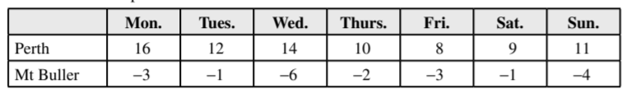
On which day is the temperature difference the greatest?
A) Monday B) Wednesday C) Friday D) Sunday

- Write an answer to these questions showing your working out. [8 marks]
- 80 +41 = | - $\frac{1}{4}+ \frac{2}{3}$
- 47 + 198 + 12= | - $1\frac{5}{6}- \frac{3}{12}$

- Write the fractions marked by a dot on the number line [4 marks]

- [2marks]
- Show the correct working and give the correct answer.

- Explain how the mistake was made

- Below is an example of where the BIMDAS rules have not been followed. [2 marks]
- Underline the mistake.
- Give the correct answer

$$(7-2+ 3)×2$$
$$=\left(7-6\right) × 2$$
$$=1 ×2$$
$=2$
- Write an answer to these questions showing your working out. [8 marks]
- 5 × 2.4 | - 0.02 × 0.3
- 35 × $10.40 | - 215 ÷ 0.4
- Find 10% of 350 [ 1mark]

- Find 5% of 110 [1 mark]

- Complete the table below by referring to the triangles, squares and circles [6 marks]

- Write a ratio for circles to triangles | - Write a ratio for triangles to squares
- Write a ratio for triangles to circles to squares | - Write a ratio to circles to total number of shapes

- Simplify the following ratios [4 marks]

- 12:24 | - 14:35 | 20L; 435 mL

- Create equivalent ratios by finding the missing numbers. [2 marks}

- 5:2 = 25:_____ b) 280:350 = 4:______

- Share 20 lollies in a ratio of 3:2 [ 3 marks]

- How much will you pay for 4.5 kg of apples, given that 2 kg cost $3.80? [2 marks]

- Compare the cost of 400 g of biscuits for $2.48 and 500 g for $3.10. Which is the better buy? [ 3marks]

End of Test

